**Accelerometer Controlled Buzzer**

**Aim :** To vary the intensity and change the tone of a buzzer by controlling an   
 accelerometer.

**Components:**  
  
**1)** **Arduino UNO Board:** Platform to build the project.  
  
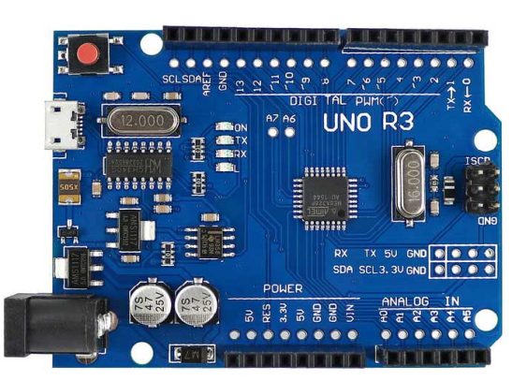

**2) 3-Axis Accelerometer:** Measures the acceleration of an object upon tilting in  
 X, Y & Z direction.

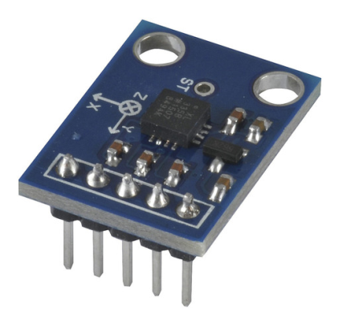

**3)Buzzer:** Audio signaling device for output.

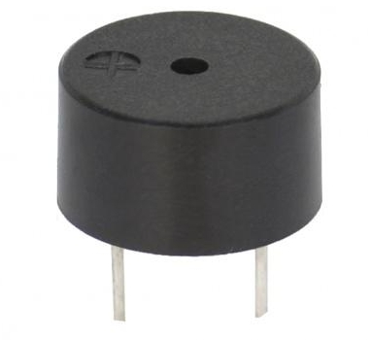

**4)** **Jumper Wires:** Connection of I/O devices with Arduino

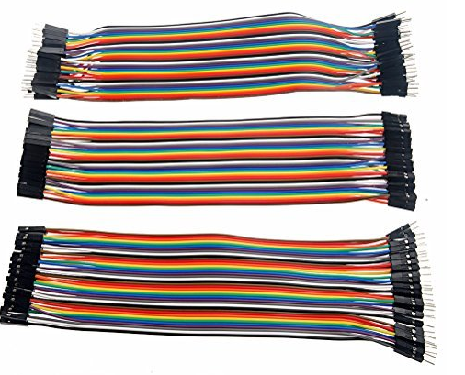

**Procedure:**  
  
1) Connect the Arduino board to computer via USB cable.  
2) Connect the 3-Axis Accelerometer to Arduino on A0, A1 & A2 pins respectively using   
 jumper wires and make one GND (ground) connection.  
3) Connect the Buzzer to Pin No. 9 and make one GND connection.  
4) Upload the code on Arduino software.  
5) Vary the position of Accelerometer to obtain different tones and intensity of   
 the Buzzer.

**Connections:**

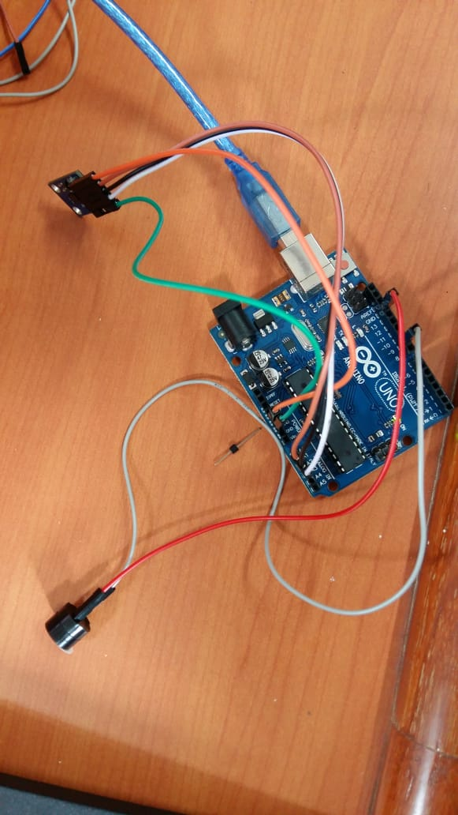

**Output on Serial Monitor:**

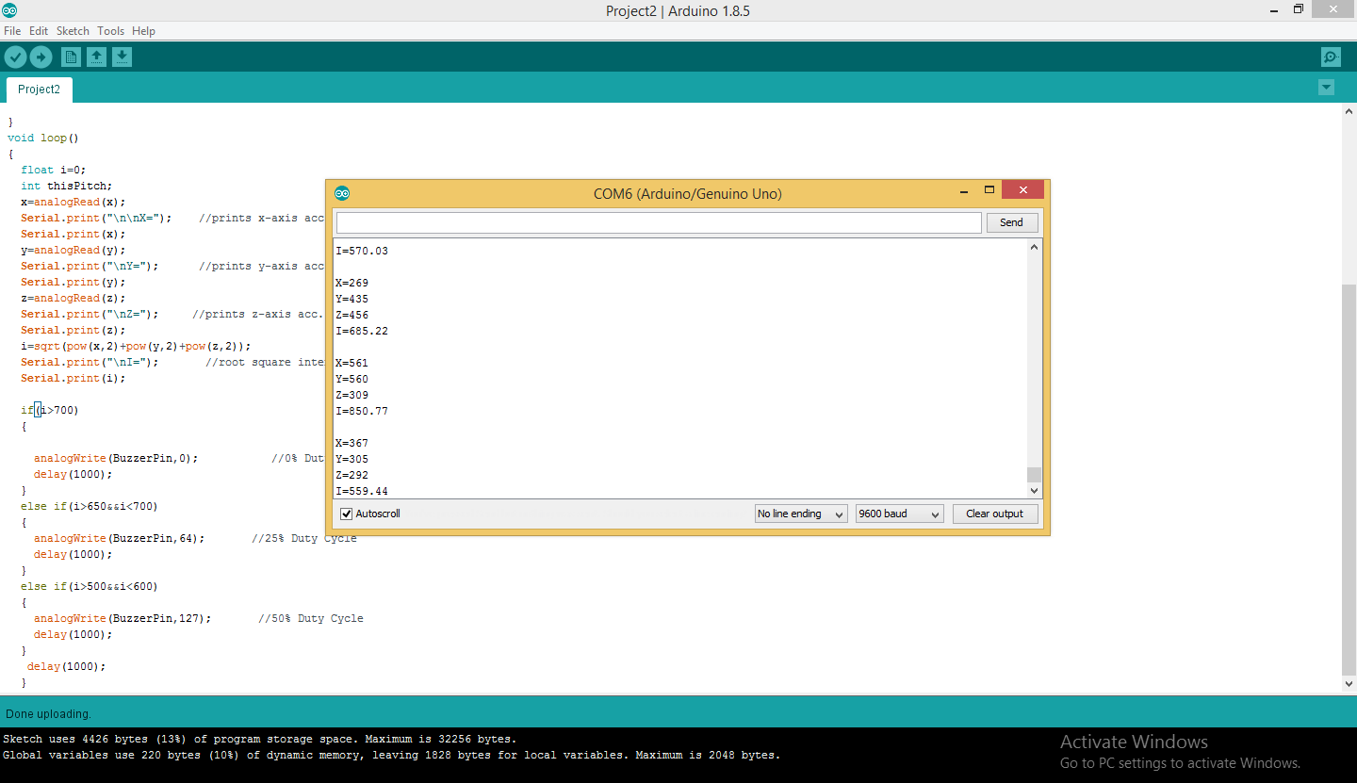

**X = Acceleration due to gravity in x-direction in terms of voltage level  
Y = Acceleration due to gravity in y-direction in terms of voltage level  
Z = Acceleration due to gravity in z-direction in terms of voltage level  
I = = Intensity**